

Eidoo — June Blog Post #3

14 June 2021

Prepared by AmaZix

eidooCARD — More Choice. More Crypto Cash. Back.

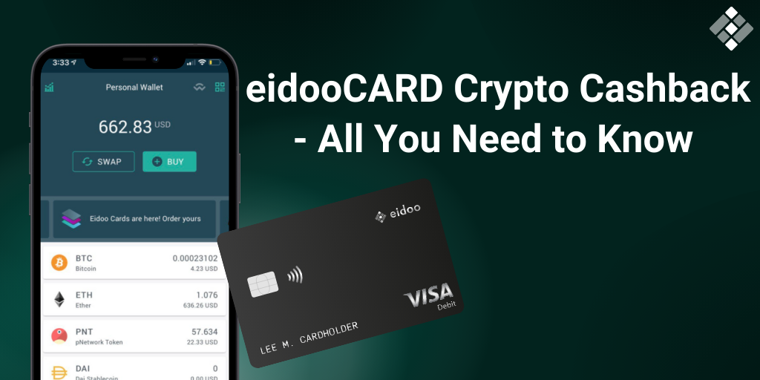

As a responsible user of DeFi products, you know better than anyone else that the best token is a used token.

We’re fully aware of that here at [Eidoo](https://eidoo.io/), which is why we have designed, and now improved, a true DeFi crypto cashback card that you can use with over 40 million merchants worldwide.

With our new and improved crypto cashback mechanism, you are going to be in for a real treat. We have fattened the eidooCARD crypto cashback percentages so that you get rewards for using the card right from the start.

Does this confirm that we at Eidoo have gone mad?

Of course it doesn't.

Our goal is to enable decentralized finance and empower you as the individual to manage your funds in the best possible way for you. With that in mind, we’ve modeled our crypto card cashback to help you earn even when simply staking or spending your funds.

Let’s see how it all works in practice.

# 5 Levels at Your Convenience

With eidooCARD in your hands, you get a certain percentage of crypto cashback with every qualifying purchase. In addition to that, your staked tokens allow you to participate in the DAO and receive additional rewards. This is a truly unique feature, wouldn’t you agree?

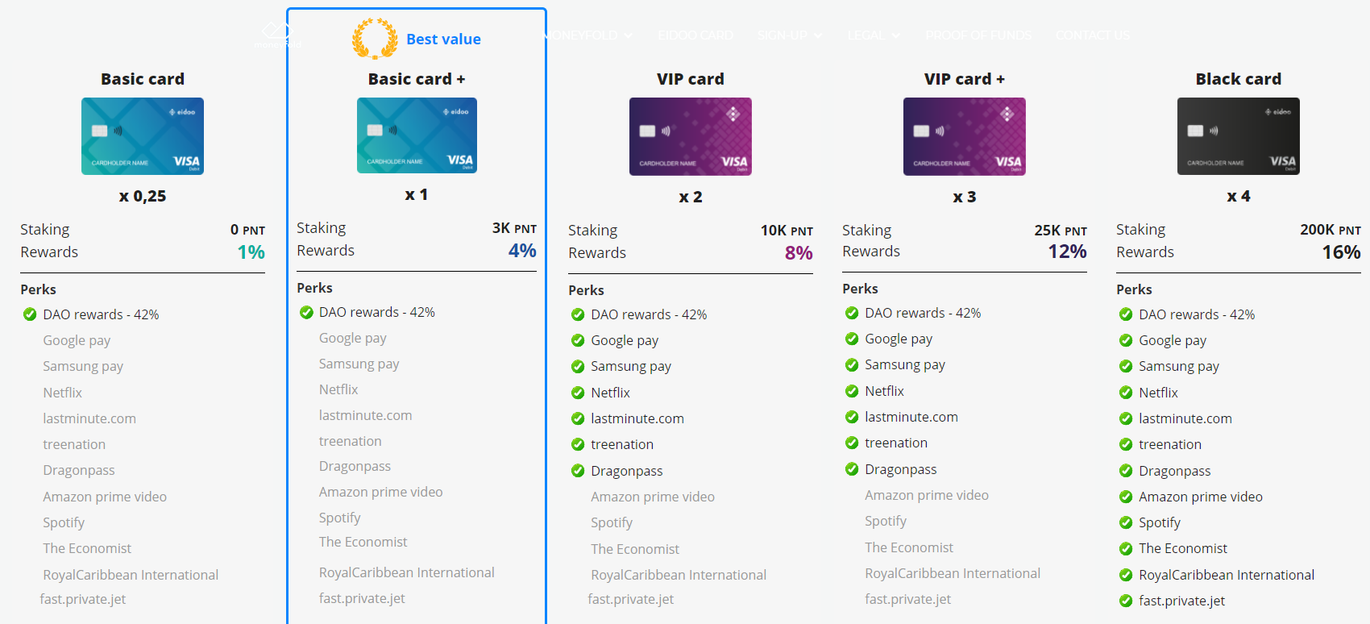

Even the **Basic eidooCARD** allows you to earn a 1% crypto cashback despite the fact that you don’t have to stake anything to get it. (If you recall, you only need to burn 20 PNT to get it).

You might still have an excuse not to try our crypto cashback card, who knows. If you are allergic to plastic with printed numbers, or have squared-shape intolerance, or you enjoy not doing what is convenient for you… Just kidding!

You think that was good? You should know by now that you can always expect more from us.

The next level is the ***Basic+*** and it’s the best-buy you can’t afford to miss. The crypto cashback reward you get is 4% for each purchase. To access this level you need to put down 3,000 PNT tokens as your stake in the [pNetwork](https://p.network/) DAO.

While we appreciate your support in the project development via the DAO mechanism, we wanted to make it worth your while as well. In addition to granting your participation in the DAO governance, the staking gives you a 42% annual return. This will change to 21% in the near future, so if you are interested, you should be quick about it. That can hardly be called a cost.

The VIP levels are designed for users who are not only interested in having a DeFi crypto card, ***VIP eidooCARD*** holders also enjoy special perks with some of our partners (Google Pay, Samsung pay, Netflix, lastminute.com, treenation, DragonPass). The staking at this level is set at 10,000 PNT tokens, always with the same profitability of 42% from active DAO participation.

And what about crypto cashback — you may ask? Twice as high as the previous option. An 8% cashback makes this level a sound crypto cashback card option.

***VIP eidooCARD+*** is the next step in crypto cashback where for 25,000 PNT staking tokens you increase your reward level from 8% to 12% with all the benefits from the previously mentioned crypto cashback level.

Finally, the ***Black eidooCARD,*** with the required staking of 200,000 PNT, gives you access to perks from even more Eidoo partners like Amazon prime video, Spotify, The Economist, Royal Caribbean International, and Fast private jet. The staking maintains 42% profitability in all the levels, but here you get the amazing 16% in crypto cashback.

If this doesn’t make spending money with a crypto card rewarding, what does?

  
Source:  
<https://imgflip.com/memegenerator/Shut-Up-And-Take-My-Money-Fry>

All this will be made possible thanks to Eidoo’s efforts, with more and more partners in the pipeline to join the Eidoo crypto cashback program. This will enhance the already outstanding benefits of the eidooCARD. 4 million PNT tokens have been allocated to support this amazing initiative.

So there's only one question left to answer: what are you waiting for to [order yours](https://site.moneyfold.co.uk/eidoo-card)?